#### Ultrasonic Heat Flow Meter

**Monitor for Cooling/Heating Water Supplying in HVAC**

Heat flow meter is developed to measure water heat supply in closed pipe and it is widely used in HVAC. We mainly provide magnetic and ultrasonic heat meter on the basis of digital flow meters without moving parts. Heat meter is also known as BTU meter, that's because BTU is one kind of energy measuring unit.Before ultrasonic heat meter released, mechanical heat meter is the main solution. But mechanical type has many disadvantages: short life, poor accuracy, accuracy degrading,easy to block,etc. Thus, it is necessary to find a good replacement. Ultrasonic heat meter can solve the problem above and an ideal solution to replace them.

**Main Structure:Flow meter+PT100/P1000 RTD for Temperature**

Ultrasonic heat flow meter is mainly comprised of three parts: ultrasonic flow meter with built-in heat function, and temperature platinum resistors. The flow meter is used to test water flow rate and PT resistors are used to gather temperature difference between inlet and outlet of water flow. The platinum resistors can be PT100 (external power supply) and PT1000(battery power supply). They can be clamp on type or insertion type. Insertion type RTD is more accurate than clamp on type,but insertion type need to cut a hole in pipe. Each set of PT100 or PT1000 will contains 2pieces and the 2pcs should be calibrated properly to ensure accuracy.

Our energy calculating system is designed on the whole consideration. Many companies are still using the separated energy calculator. Our ultrasonic flow/heat meters provide Modbus and M-BUS protocol for network management.

In order to have an understanding to heat flow meter, we can borrow the classification from our ultrasonic flow meters as below:

**Portable Clamp On Heat Flow Meter**

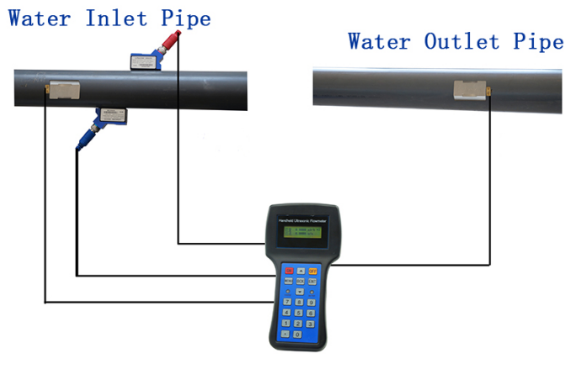

Portable heat flow meter is designed on battery powered portable ultrasonic flow meter.It is equipped with clamp on flow sensors and clamp on RTD resistors. The configuration doesn't need to cut pipe and provides mobile and convenient measurement of water energy flow. It can be used for flow/energy check and survey.

Portable heat meters have two types: handheld type and portable type. Built-in mini printer or data logger are optional for data recording. User can select it as requirement. After fully recharging, the portable heat meter can work for 10-24 hours decided by different types. Longer battery can be made,but it will enlarge the size of flow converter.

For the technical specification, please refer to that of handheld&portable ultrasonic flow meters.

**Fixed Clamp on Heat Meter**

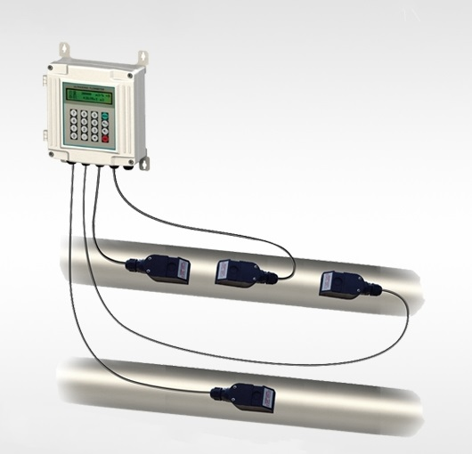

Fixed clamp on heat flow meter is used for exact size pipe for long-term, and it doesn't need to move it often like portable type. It is usually powered by external power,mainly have 110-240Vac or 8-36Vdc or solar power. Both ultrasonic flow sensors and PT100 resistors are clamp on type and doesn't need to cut pipe. So it inherits many advantages of clamp on flow meters. The flow/energy converter part can select wall mounted unit,desktop unit,low cost unit,etc.

**Fixed Insertion Heat Flow Meter**

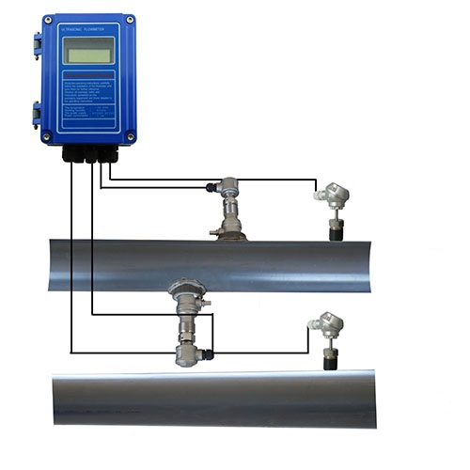

Insertion ultrasonic flow sensors are suitable for pipe size over DN50mm. It is widely used for its stable performance and light-weight. It just requires to drill holes on pipe and doesn't cause big damage to pipe. Meanwhile, for poor condition or cement pipe, it is an ideal choice where clamp on flow meter can't work well. For insertion heat meter, it can be powered by battery or external AC&DC power. When battery power, use insertion PT1000 resistor. When external power, insertion PT100 is selected.

**Fixed Inline Heat BTU Meter**

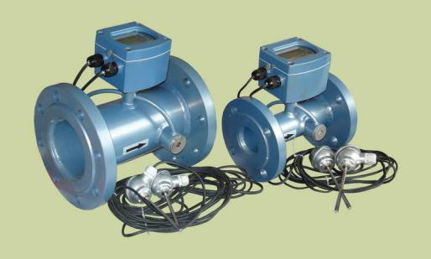

Inline type is the most often used for flow meter or BTU meter. BTU meter usually refers to residential heat meter for home using. Its pipe size is usually DN15-DN25 and battery power. In the past,mechanical BTU meter is the main selection,but ultrasonic BTU meters are replacing it. Magnetic BTU meters have ever been an option,but it can't compete with ultrasonic type. Thus, ultrasonic BTU meter has the promising prospect than others.

Except BTU meter,inline heat flow meter are also widely used for bigger pipe size. Though it requires to cut pipe largely,its installing is more convenience. And since historic reason, many existing BTU meters are inline structure,inline ultrasonic heat meters can make it quick to replace.

**Inline Magnetic Heat Meter**

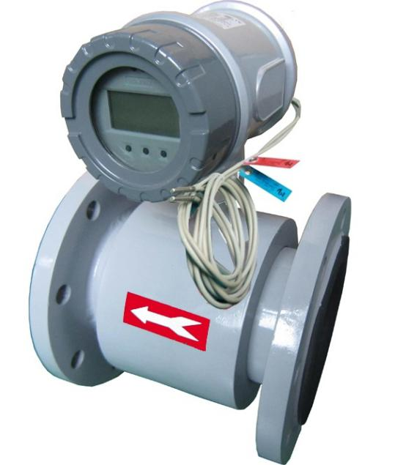

We can also make magnetic heat meters as requirement. Equipped with PT100 resistor,electromagnetic flow meter can be functioned magnetic heat flow meter. Like fixed ultrasonic heat meter, it is usually external power and used for certain size pipe for long-term. It can provide higher accuracy,but better accuracy means higher cost. As the accuracy of our wetted ultrasonic flowmeter can reach 0.5 class, magnetic heat meter is not necessary solution. That's why magnetic heat flow meter is not so popular like ultrasonic meter.

SOLUTION NOT RECOMMENDATION:

1).External Energy Calculator. Some manufacturers can't add energy calculating system to their ultrasonic flowmeters or flow device,thus they have to borrow external energy calculator. This solution has no comprehensive system design,its performance can't be well ensured.

2).Analog Temperature Sensor. Several companies who still use 4-20mA temperature sensor to gather temperature value. This is not recommended because 4-20mA is analog signal and  will reduce accuracy of temperature value. As a result,the accuracy of heat meter is degraded.

3).Modbus protocol. Modbus is a kind of very popular industry communication protocol for network monitor and management. Several heat meters only use very rare register address for Modbus protocol. This is not real Modbus communication. You can't get benefits from real complete Modbus protocol.

**Typical Application-HVAC Energy Monitor&Management**

For heating/cooling supply, it will require a measurement device to test how much energy is transported and consumed. Based on the measured value, the supplying party can charge it accordingly. Meanwhile, users can have an exact value knowing how much they have consumed. Thus, ultrasonic heat flow meters are introduced. With clamp on flow and temperature, the BTU meters don't need to cut pipe and won't damage your existing pipe. By Modbus protocol of our heat flow meters, users can monitor the whole network by your control center. This is a very ideal solution with very high cost-effective.

**What is the difference between a heat meter and a flow meter?**

Flow meter is used to measure flow rate and velocity of flow and gas. Heat meter is used to test the energy that has been consumed. Usually, flow meter is the basis of heat meters. Take water energy supplying as example, the main heat meters are mechanical type, magnetic type and ultrasonic type. Ultrasonic type should be the main selling type at present.

Ultrasonic heat meter is developed on the transit-time ultrasonic flow meters. Equipped with PT100/PT1000 temperature resistors, ultrasonic flow meters can be functioned as ultrasonic heat meters. A pair (2pieces) of PT100 will be separately installed on supplying pipe and discharging pipe, then related temperature difference is gained. By temperature difference and corresponding flow rate, heat meters will calculate consumed energy accordingly.

From：https://www.abestmeter.com/heat-flow-meter/